**Sentiment Analysis of Social Media**

A Minor Project Report Submitted To

Rajiv Gandhi Proudyogiki Vishwavidyalaya, Bhopal

Towards Partial Fulfilment for the Award Of

Bachelor of Technology

In

**ARTIFICIAL INTELLIGENCE & DATA SCIENCE**

Submitted By

**Kundan Malviya (0863AD211033)**

**Pukhraj Garasiya (0863AD211042)**

**Rohit Thakur (0863AD211046)**

**Rohit Kumar (0863AD211045)**



Under the Supervision of

**Prof. Dr. Dipti Chauhan**

Session: 2023-2024

**Department of Artificial Intelligence & Data science**,

**Prestige Institute of Engineering, Management and Research, Indore (M.P.)**

[An Institution Approved By AICTE, New Delhi & Affiliated To RGPV, Bhopal]

**PRESTIGE INSTITUTE OF ENGINEERING MANAGEMENTAND RESEARCH**

**INDORE (M.P.)**

**DECLARATION**

We **Kundan Malviya, Pukhraj Garasiya, Rohit Thakur, and Rohit Kumar** hereby declare that the project entitled “**Sentiment Analysis of Social Media**”, which is submitted by us for the partial fulfilment of the requirement for the award of Bachelor of Technology in Artificial Intelligence & Data Science to the Prestige Institute of Engineering, Management and Research, Indore (M.P.)*.* Rajiv Gandhi Proudhyogiki Vishwavidyalaya, Bhopal, comprises my own work and due acknowledgement has been made in text to all other material used**.**

Signature of Students:

Date:

Place:

**PRESTIGE INSTITUTE OF ENGINEERING MANAGEMENTAND RESEARCH**

**INDORE (M.P.)**

**DISSERTATION APPROVAL SHEET**

This is to certify that the dissertation entitled **“Sentiment Analysis of Social Media”** submitted by **Kundan Malviya (0863AD211033), Pukhraj Garasiya (0863AD211042), Rohit Thakur (0863AD211046), and Rohit Kumar (0863AD211045)** to the Prestige Institute of Engineering, Management and Research, Indore (M.P.) is approved as fulfilment for the award of the degree of Bachelor of Technology in Artificial Intelligence & Data Science by Rajiv Gandhi Proudhyogiki Vishwavidyalaya, Bhopal, (M.P.).

**Internal Examiner External Examiner**

Date: Date:

**HOD, AI & DS**

**Dr. Dipti Chauhan**

**PIEMR, INDORE**

**PRESTIGE INSTITUTE OF ENGINEERING MANAGEMENTAND RESEARCH**

**INDORE (M.P.)**

**CERTIFICATE**

This is certified that project entitled “**Sentiment Analysis of Social Media**” submitted by **Kundan Malviya, Pukhraj Garasiya, Rohit Thakur and Rohit Kumar** is a satisfactory account of the bona fide work done under our supervision and is recommended towards partial fulfilment for the award of the degree Bachelor of Technology in Artificial Intelligence & Data Science to Rajiv Gandhi Proudyogiki Vishwavidyalaya, Bhopal (M.P.) .

**Date:**

**Enclosed by:**

**Project Guide Project Coordinator Professor & Head, AI & DS**

Dr. Dipti Chauhan Ms. Diksha Bharawa Dr. Dipti Chauhan

**Dr. Manojkumar Deshpande**

**Director**

**PIEMR, Indore**

**PRESTIGE INSTITUTE OF ENGINEERING MANAGEMENTAND RESEARCH**

**INDORE (M.P.)**

**ACKNOWLEDGEMENT**

After the completion of Minor project work, words are not enough to express my feelings about all these who helped me to reach my goal; feeling above this is my indebtedness to the almighty for providing me this moment in life.

First and foremost, we take this opportunity to express my deep regards and heartfelt gratitude to my project guide **Dr. Dipti Chauhan and Prof. Diksha Bharawa, Department of Artificial Intelligence & Data Science, PIEMR, Indore** for their inspiring guidance and timely suggestions in carrying out my project successfully. They are also the constant source of inspiration for me. Working under their guidance has been an opportunity for me to learn more and more.

We are extremely thankful to **Dr. Dipti Chauhan, (HOD, AI & DS)** for her co-operation and motivation during the project. I extend my deepest gratitude to **Dr. Manojkumar Deshpande, Director, PIEMR, and Indore** for providing all the necessary facilities and true encouraging environment to bring out the best of my endeavour’s.

We like to thank all the teachers of our department for providing invaluable support and motivation. I remain indebted to all the non-teaching staff of our Institute who has helped me immensely throughout the project.

We are also grateful to my friends and colleagues for their help and co-operation throughout this work. Last but not least; we thank my family for their support, patience, blessings and understanding while completing my project.

**Name of Students:**

**Kundan Malviya (0863AD211033)**

**Pukhraj Garasiya (0863AD211042)**

**Rohit Thakur (0863AD211046)**

**Rohit Kumar (0863AD211045)**

**INDEX**

**Declaration I**

**Dissertation Approval Sheet II**

**Certificate III**

**Acknowledgement IV**

**Table of Contents V**

**List of Tables VI**

**List of Figures VII**

**TABLE OF CONTENTS**

# CHAPTER 1 INTRODUCTION

1.1 Introduction…………………………………………………………………….………2

1.2 Motivation………………………………………………………...................................2

1.3 Objective…………………………………………………………………….…………3

1.4 Analysis …………………………………………………………..................................3

1.4.1 Functional Requirements ……………………………………………...…......4

1.4.2 Non-functional Requirements …………………………………………..……5

# CHAPTER 2 BACKGROUND AND RELATED WORK

2.1 Problem Statement ……………………………………………………………………9

2.2 Background and Related Work………………………………………………………..9

2.2.1 Background Work …………………………………………………………..9

2.2.2 Literature survey ……………………………………………………….......12

2.3 Solution Approach (*methodology and technology used)…………*……………………16

# CHAPTER 3 DESIGN (UML AND DATA MODELING)

3.1 UML Modeling

3.1.1 Sub Systems……………………………………………………………….….20

3.1.2 Class Diagram……………………………………………................................22

3.1.3 Sequence Diagram ………………………………………................................22

3.1.4 Activity Diagram…………………………………………...............................23

3.1.5 Use Case Diagram………………………………………….............................23

3.2 Data Modeling

3.2.1 Data Flow Diagram……………………………………….............................24

# CHAPTER 4 IMPLEMENTATION

4.1 Tools Used…………………………………………………………………….……...26

4.2 Technology…………………………………………………………………………...27

4.3 Testing ……………………………………………………………………….……...28

4.3.1 Testing Approach. …………………………………………………………..29

4.3.2 Test Cases……………………………………………………………………31

4.3 User manual……………………………………………………………………………34

# CHAPTER 5 PROJECT PLAN

5.1 Effort Schedule & Cost estimation ……………………………………………………39

5.2 Work Breakdown Structure…………………………………………………………….40

5.3 Deviation from original plan and correction applied……………………………….…..41

5.4 User manual…………………………………………………………………………….42

# CHAPTER 6: Project Screenshot

# CHAPTER 7 CONCLUSION & FUTURE SCOPE

7.1 Conclusion………………………………………………………....................................42

7.2 Future Scope……………………………………………………………….……………42

**Bibliography……………………………………………………………………..………….43**

**Appendix A: Snapshots or Screenshots with description………………………………44**

**LIST OF TABLES**

1. **Dataset sequence in CSV Format………………………………………………….……4**

**CHAPTER 1**

**INTRODUCTION**

**1.1 INTRODUCTION**

Sentiment analysis of social media is a powerful computational technique that involves the use of natural language processing, text analysis, and computational linguistics to systematically identify, extract, quantify, and study subjective information from textual data. With the explosion of user-generated content on various social media platforms, sentiment analysis has become an invaluable tool for understanding and analyzing public opinion, attitudes, and emotions expressed by individuals or groups online.

By employing machine learning and deep learning algorithms, sentiment analysis can effectively categorize text into positive, negative, or neutral sentiment categories, enabling businesses, organizations, and researchers to gain valuable insights into customer preferences, public opinion, and brand perception. This process not only helps in understanding customer satisfaction and feedback but also aids in monitoring brand reputation, conducting market research, and making data-driven decisions for improved customer engagement and product development.

Moreover, sentiment analysis of social media has proven to be instrumental in monitoring and analyzing trends, public sentiment shifts, and emerging issues, thus enabling proactive crisis management and timely response to potential PR challenges. By harnessing the power of sentiment analysis, companies can adapt their marketing strategies, tailor their products and services to meet customer needs, and enhance overall customer experience, ultimately leading to improved brand loyalty and increased market competitiveness.

Overall, the application of sentiment analysis in social media has transformed the way businesses and researchers interpret and leverage vast amounts of textual data, enabling them to stay ahead of market trends, understand consumer behavior, and make informed decisions that drive business success and foster meaningful connections with their target audience.

**1.2. Motivation**

The motivation behind developing the Social Media Sentiment Analysis Tool stems from several key considerations:

1. Understanding User Sentiment:

Social media platforms are rich sources of diverse opinions, emotions, and sentiments. By accurately analyzing user sentiments, businesses, researchers, and individuals can gain valuable insights into public opinion, customer satisfaction, and trends.

1. Decision Support for Businesses:

For businesses, understanding customer sentiment is pivotal. The tool empowers organizations to make data-driven decisions, whether it's refining marketing strategies, improving products and services, or addressing customer concerns proactively.

1. Enhancing Social Listening:

Social listening is crucial for brand management and reputation monitoring. This tool aids in tracking and analyzing sentiments expressed toward a brand or product across social media, enabling timely responses and reputation management.

1. Customization and Adaptability:

The tool is designed with customization in mind, allowing users to adapt sentiment analysis models to specific domains, industries, or cultural nuances. This flexibility ensures relevance and accuracy in various contexts.

1. Real-time Analysis for Timely Action:

With features like real-time analysis of social media feeds, the tool enables users to stay abreast of sentiment trends as they unfold. This timely information is vital for crisis management, event monitoring, and staying connected with user sentiments.

1. Research and Trend Analysis:

Researchers can utilize the tool to study societal trends, public reactions to events, or sentiment shifts over time. This facilitates academic research, market analysis, and a deeper understanding of the dynamics of online discourse.

1. Empowering Individuals:

Beyond organizational applications, the tool provides individuals with the ability to gauge public sentiment on various topics, stay informed about trending discussions, and engage meaningfully in online conversations.

**1.3 Objective**

The objective for sentiment analysis of social media is to understand and measure the feelings and opinions of people who express themselves on social media platforms. Sentiment analysis can help brands, businesses, and individuals to monitor their online reputation, identify customer needs and preferences, improve customer service, and gain valuable insights from social media data. Sentiment analysis uses natural language processing (NLP) and machine learning techniques to analyze the text data from social media posts and comments. It can classify the text as positive, negative, or neutral, or assign a numerical score to indicate the intensity of the sentiment. Some sentiment analysis tools can also detect more complex emotions, such as anger, joy, sadness, or surprise. Sentiment analysis can be applied to various social media platforms, such as Facebook, Twitter, Instagram, TikTok, etc. To perform sentiment analysis on social media, one needs to collect and preprocess the text data, choose or build a sentiment analysis model, apply the model to the data, and visualize or interpret the results. There are many tools and frameworks available for sentiment analysis on social media, such as Sprout Social, Hootsuite, etc. These tools can help users to easily perform sentiment analysis on social media data and gain insights from the results. For more information about sentiment analysis on social media.

* 1. **Analysis**
     1. **Functional Requirements**

When it comes to sentiment analysis of social media, the functional requirements become more specific to the nature of social media data. Some additional functional requirements for sentiment analysis of social media include:

**(i). Social Media Data Integration:** The system should be able to integrate with various social media platforms to retrieve and analyze data from sources such as Twitter, Facebook, Instagram, LinkedIn, and others.

**(ii). Hashtag and Mention Analysis:** The capability to handle hashtags and mentions is essential, as these are crucial elements of social media posts that can provide context and influence sentiment analysis results.

**(iii). Emoticon and Emoji Interpretation:** The system should be able to interpret and analyze the sentiment conveyed by emoticons and emojis, as these elements are commonly used in social media communication and can significantly impact the overall sentiment of a post.

**(iv). Trend Analysis:** The ability to identify and analyze sentiment trends across social media platforms, tracking how sentiment changes over time, can provide valuable insights into the public's evolving opinions and attitudes.

**(v). Geolocation-Based Analysis:** For some applications, the system may need to support geolocation-based sentiment analysis, allowing organizations to understand sentiment variations across different regions or locations.

**(vi). Influencer Analysis:** The capability to identify influential users or influencers within social media networks and analyze the sentiment associated with their content can provide valuable insights for marketing and brand management purposes.

**(vii). Data Privacy and Security:** Given the sensitive nature of social media data, the system should adhere to strict data privacy and security standards to ensure the protection of user information and compliance with relevant data protection regulations.

**(viii). Real-Time Monitoring and Alerting:** The system should be capable of monitoring social media platforms in real-time, providing alerts or notifications for significant shifts in sentiment, emergent trends, or potential PR crises.

**(ix). Integration with Social Listening Tools:** Integration with social listening tools can enhance the sentiment analysis process by providing a more comprehensive view of social media conversations and public opinions surrounding a brand, product, or topic.

**(x). User Profiling and Segmentation:** The system should be able to create user profiles and segment users based on their sentiment patterns, allowing for more targeted marketing campaigns and personalized communication strategies.

By meeting these functional requirements, a sentiment analysis system designed for social media can provide organizations with valuable insights into customer opinions, preferences, and trends, enabling them to make data-driven decisions and effectively manage their online reputation.

* + 1. **Non-functional Requirements**

Non-functional requirements in the sentiment analysis of social media of the system's operational aspects and constraints. These requirements focus on the performance, security, and scalability of the sentiment analysis system, among other critical aspects. Some non-functional requirements for sentiment analysis of social media include:

**(i). Performance:** The system should be able to process a large volume of social media data in real-time or near real-time, ensuring minimal latency in sentiment analysis to provide timely insights.

**(ii). Scalability:** The system should be capable of scaling horizontally to handle sudden spikes in data volume, especially during events, product launches, or other instances where social media activity significantly increases.

**(iii). Robustness and Reliability:** The sentiment analysis system should be robust and reliable, capable of handling noisy and unstructured social media data, as well as being resilient to fluctuations in data quality and content.

**(iv). Accuracy and Confidence Levels:** The system should be able to provide sentiment analysis results with high accuracy, along with a measure of confidence for each analysis to enable users to gauge the reliability of the results.

**(v). Data Security and Privacy:** The sentiment analysis system must comply with data privacy regulations and ensure the security of user data and sensitive information collected from social media platforms.

**(vi). Adaptability to Evolving Language:** The system should be able to adapt to the constantly evolving nature of language used in social media, including the incorporation of new slang, memes, and colloquial expressions.

**(vii). Multi-platform Compatibility:** The system should be compatible with various social media platforms, APIs, and data formats to ensure seamless integration and data interoperability.

**(viii). Resource Efficiency:** The system should utilize system resources efficiently, optimizing memory and processing power to handle large datasets while minimizing hardware requirements and operational costs.

**(ix). Usability and User Interface:** The sentiment analysis system should have a user-friendly interface that allows users to interact with the system easily, providing intuitive visualization and reporting features for better understanding and interpretation of the sentiment analysis results.

**(x). Compliance with Social Media APIs:** The system should adhere to the usage policies and guidelines of different social media platforms to ensure uninterrupted data access and prevent any potential issues related to API usage limits or restrictions.

By these non-functional requirements, a sentiment analysis system can ensure optimal performance, security, and user experience while processing and analyzing social media data to derive valuable insights and inform decision-making processes.

**CHAPTER 2 BACKGROUND AND RELATED WORK**

# 2.1 Problem Statement

A Problem statement for **Sentiment Analysis of Social Media**:

"Despite the exponential growth of user-generated content on social media platforms, the lack of efficient sentiment analysis tools poses a significant challenge for businesses and organizations seeking to extract actionable insights from the vast volumes of textual data. Inaccuracies in sentiment classification, the inability to capture nuanced emotions, and the challenges posed by multilingual and multimodal content hinder the comprehensive understanding of consumer sentiments and preferences. Moreover, the absence of real-time and context-aware sentiment analysis techniques limits the ability to monitor and respond to dynamic changes in public opinion, thereby impeding effective brand management and customer engagement strategies. This necessitates the development of advanced sentiment analysis methodologies that can address these challenges, providing businesses with a more holistic understanding of user sentiments, emotions, and attitudes expressed across diverse social media platforms. "

**2.2 Background and Related Work**

**2.2.1 Background Work**

The background work of sentiment analysis of social media involves using natural language processing and machine learning techniques to analyze the text data from social media platforms and extract the sentiment behind them. Sentiment analysis can help businesses understand how their customers feel about their products, services, or brand image, and take appropriate actions to improve customer satisfaction and loyalty.

There are different approaches to perform sentiment analysis, such as rule-based, automated, and hybrid systems. Rule-based systems rely on predefined rules and lexicons to assign sentiment scores to words or phrases. Automated systems use machine learning models to learn from labeled data and classify new text data into sentiment categories. Hybrid systems combine both rule-based and automated methods to leverage the advantages of both.

Some of the common steps involved in sentiment analysis are:

* **Data collection:** This involves gathering text data from various social media sources, such as Twitter, Facebook, Instagram, etc. The data can be filtered by keywords, hashtags, mentions, or other criteria.
* **Data preprocessing:** This involves cleaning and transforming the text data into a suitable format for analysis. Some of the common techniques include tokenization, normalization, lemmatization, stemming, stop word removal, etc.
* **Feature extraction:** This involves selecting and extracting relevant features from the text data that can represent the sentiment behind them. Some of the common features include word frequency, n-grams, part-of-speech tags, sentiment lexicons, etc.
* **Model training:** This involves using a machine learning algorithm to learn from the features and labels of the training data and create a sentiment classifier. Some of the common algorithms include logistic regression, naive Bayes, support vector machines, decision trees, neural networks, etc.
* **Model evaluation:** This involves testing the performance of the sentiment classifier on unseen data and measuring its accuracy, precision, recall, F1-score, etc.
* **Model deployment:** This involves applying the sentiment classifier to new text data from social media and obtaining the sentiment scores or categories for each text.

Sentiment analysis is a challenging and evolving task that requires constant improvement and adaptation to different domains, languages, and contexts. Some of the current challenges and trends in sentiment analysis include:

* Handling sarcasm, irony, humor, and slang in social media text
* Detecting fine-grained sentiments such as emotions, aspects, intents, etc.
* Incorporating multimodal data such as images, videos, emojis, etc.
* Using deep learning models such as transformers, BERT, GPT-3, etc.
* Developing explainable and ethical sentiment analysis systems

**2.2.2 Literature survey**

This section illustrates other similar work related to analyzing sentiments. Most of these approaches analyse sentiments as positive and negative while some approaches are in research level and few more are commercially available.

***(i).Adobe Social Analytics***

Adobe Social Analytics basically measures the impact of social media on businesses by understanding how conversations on social networks and online communities influence marketing performance. After capturing and understanding the conversations going on, it correlates the impact of those conversations with key business matrices such as revenue and brand value. Other than that it measures the interactions that businesses have with their customers in social media including how Facebook posts drive site visitors and purchase behaviours . Adobe Social Analytics uses a natural language processing algorithm to implement sentiment analysis.

***(ii). Brandwatch Sentiment Analysis***

Brandwatch is also a sentiment analysis tool developed by a team of PhD qualifiers in the United Kingdom; this is also commercially available currently. Through this tool they are trying to access whether a sentiment is positive, negative or neutral.

***(iii). TweetFeel***

TweetFeel is also a web tool that analyzes sentiments of the given input through the twitter social media. This gathers real time data on Twitter, about the search items and evaluates those tweets into positive and negative categories in real time. This uses machine learning based sentiment analysis which enables to get much clearer feeling about sentiments.

***(iv). Social Mention***

Social Mention is a social media search and analysis platform which analyses user sentiments through social media. This is also an online tool that allows tracking what people are saying about a particular brand, product or topic in real time. This tool allows the user to define a time period in which to analyze user sentiments.

***(v). Sentiment140***

This is an online tool for analyzing sentiments of Twitter social network. This tool allows discovering the sentiment of a brand, product or topic on Twitter. This was created by three Computer Science graduate students at Stanford University and their main focus is analyzing the languages English and Spanish. Sentiment140 basically states whether the specified brand, product or topic is positive, negative or neutral.

**2.3 Solution Approach (methodology and technology used)**

**2.3.1. METHODOLOGY-**

1. Data Collection:

Collect social media data from Twitter, including comments or tweets related to the product or topic of interest.

2. Data Preprocessing:

Clean and preprocess the collected data. This may involve removing irrelevant information, handling special characters, and tokenizing the text.

3. Sentiment Analysis:

Apply a pre-trained NLTK model for sentiment analysis. This model will classify the text into positive, negative, or neutral sentiments based on the content.

4. Visualization:

Visualize the sentiment analysis results. Categorize and present the comments as positive, negative, or neutral, allowing users to easily interpret the sentiment of each comment.

5. Website Integration:

Integrate the sentiment analysis tool into a website or web application, ensuring it is user-friendly and accessible to visitors.

6. User Interaction:

Enable users to interact with the integrated tool on the website. Users can input different comments or tweets for analysis.

# CHAPTER 3

# DESIGN (UML AND DATA MODELING)

**3.1 UML Modeling**

3.1.1 Sub Systems

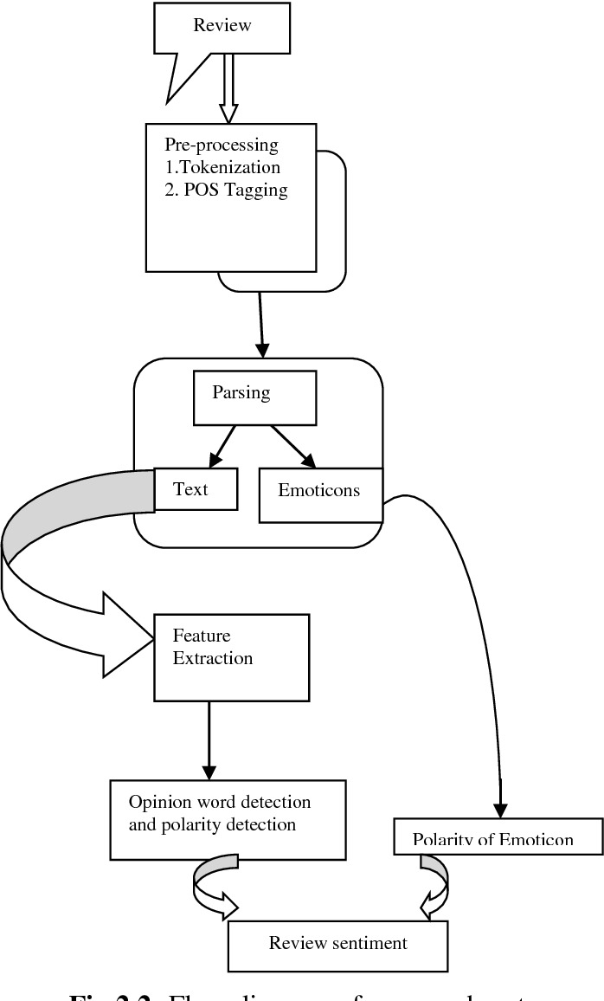

Fig.1

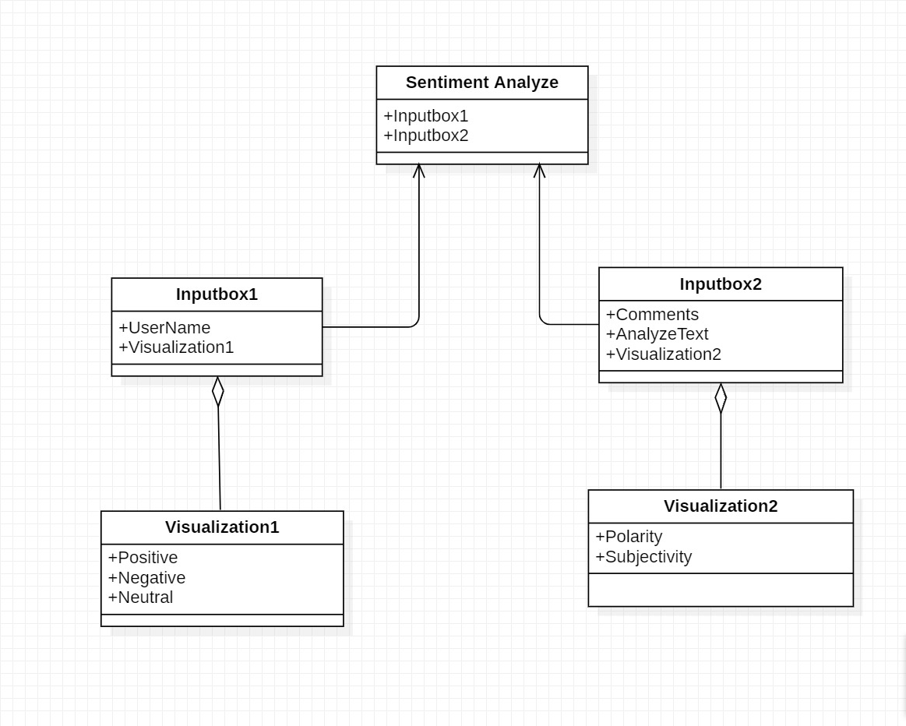3.1.2 Class Diagram

Fig. 2

3.1.3 Sequence Diagram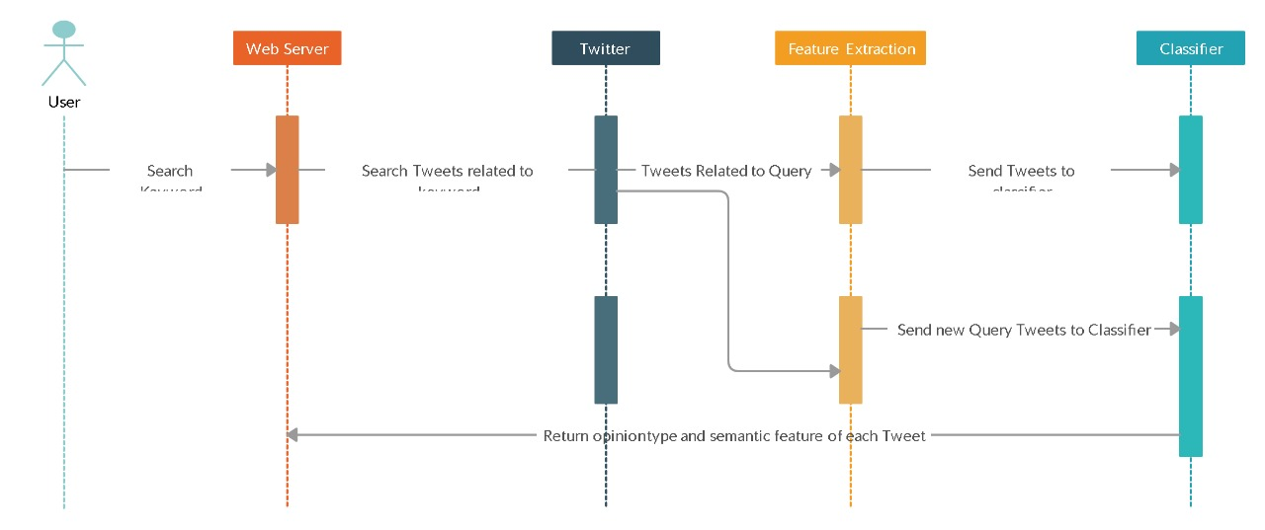

Fig. 3

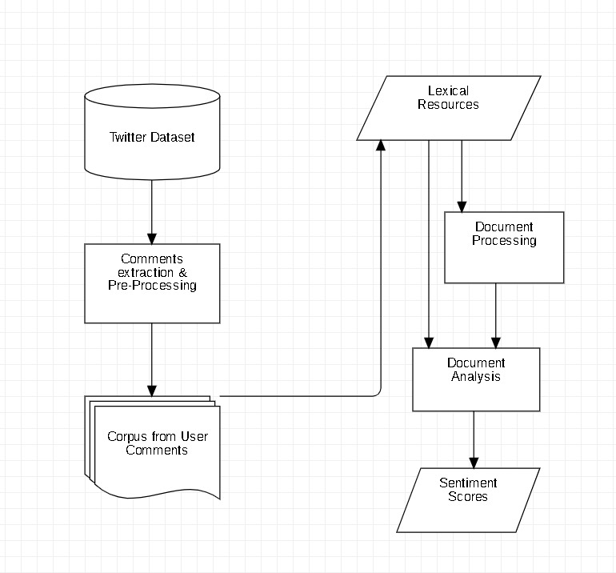3.1.4 Activity Diagram

Fig. 4

3.1.5 Use Case Diagram

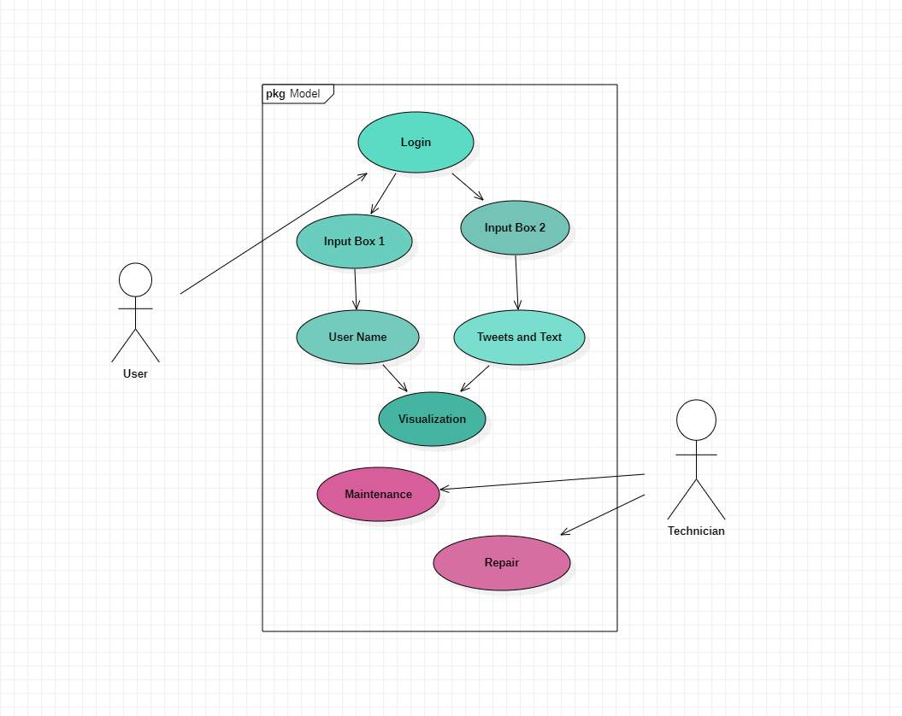

Fig. 5

**3.2 Data Modeling**

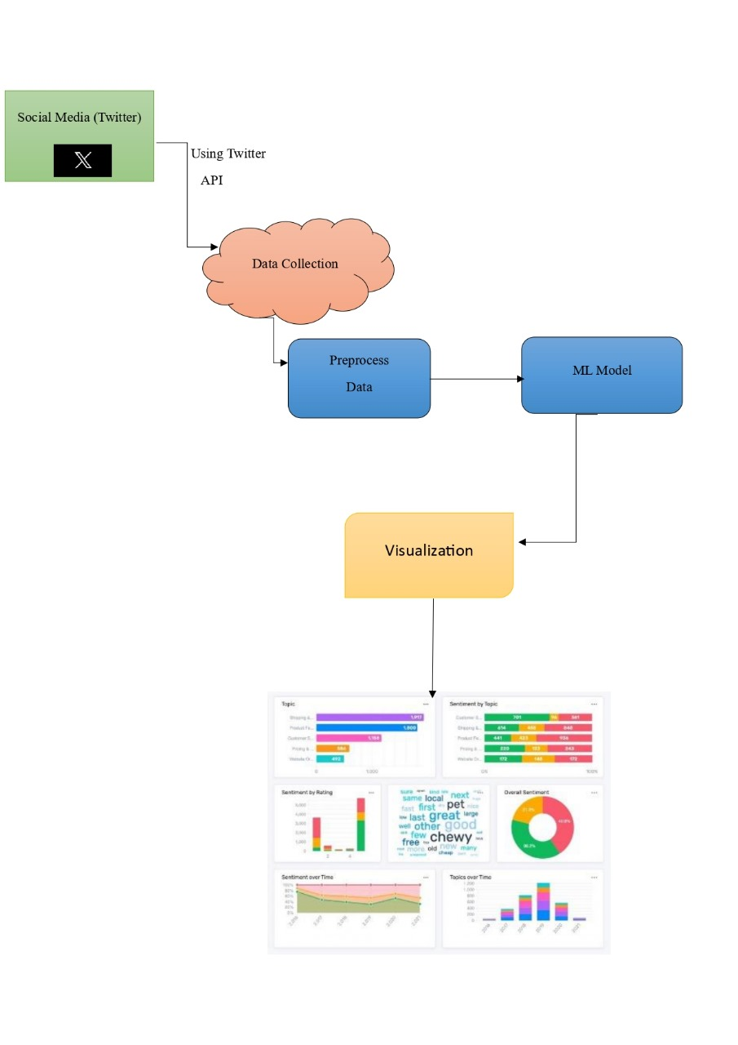3.2.1 Data Flow Diagram

Fig. 6

# CHAPTER 4 IMPLEMENTATION

* 1. **Tools and Technology**

4.1.1 Python : Python excels in sentiment analysis with rich libraries, NLP tools, machine learning support, and a robust community for integration.



Fig. 7

4.1.2 Pandas : Pandas, a Python library, simplifies data manipulation and analysis with its powerful data structures, making it invaluable for sentiment analysis.



Fig. 8

4.1.3 Streamlit : Streamlit simplifies creating web apps with Python, enabling easy sharing of sentiment analysis results. It's user-friendly, interactive, and efficient.



Fig. 9

4.1.4 Textblob : TextBlob, a Python library, streamlines text processing and sentiment analysis with a simple API, making NLP tasks accessible for beginners.



Fig. 10

4.1.5 VADER : VADER (Valence Aware Dictionary and sEntiment Reasoner) is a Python library for sentiment analysis, designed specifically for social media text.

4.1.6. Matplotlib : Matplotlib, a Python library, facilitates data visualization, including sentiment analysis results, with a wide range of customizable plots and charts.



Fig. 11

* 1. **Testing** 
     1. **Testing Approach**

1. Data Collection:

Objective: Gather a diverse dataset representative of social media content.

Scope: Collect samples from various platforms with different tones and languages.

1. Preprocessing:

Objective: Prepare data for analysis, including text cleaning and normalization.

Scope: Remove noise, handle emojis, and standardize text to enhance the accuracy of sentiment analysis.

1. Training Data Preparation:

Objective: Create a labeled dataset for training the sentiment analysis model.

Scope: Manually label a subset of data for training; ensure a balanced representation of sentiment classes.

1. Model Training:

Objective: Develop and train the sentiment analysis model.

Scope: Use machine learning or deep learning algorithms; tune hyperparameters for optimal performance.

1. Model Evaluation:

Objective: Assess the accuracy and performance of the trained model.

Scope: Utilize metrics like accuracy, precision, recall, and F1 score; consider cross-validation.

1. Testing on Social Media Data:

Objective: Apply the trained model to social media data.

Scope: Evaluate model performance on real-world social media content; consider diverse sources and languages.

1. Handling Imbalanced Data:

Objective: Address imbalances in sentiment class distribution.

Scope: Apply techniques like oversampling, undersampling, or using weighted classes during training.

1. Handling Sarcasm and Irony:

Objective: Ensure the model can identify and handle sarcastic or ironic statements.

Scope: Include sarcastic and ironic samples in the dataset; fine-tune the model accordingly.

1. Cross-Platform Testing:

Objective: Validate the model's performance across different social media platforms.

Scope: Test the model on data from various platforms to account for platform-specific language and trends.

1. User Feedback Integration:

Objective: Gather feedback from end-users.

Scope: Collect feedback on misclassifications, false positives, and false negatives to continuously improve the model.

1. Monitoring and Maintenance:

Objective: Establish ongoing monitoring and maintenance procedures.

Scope: Regularly reevaluate the model's performance, update training data, and retrain the model to adapt to evolving language and trends.

**4.3.2 Test Cases**

1. Positive Sentiment:

Test Case: Input a social media post containing positive sentiment.

Expected Outcome: The sentiment analysis model should correctly classify the sentiment as positive.

2. Negative Sentiment:

Test Case: Input a social media post containing negative sentiment.

Expected Outcome: The sentiment analysis model should correctly classify the sentiment as negative.

3. Neutral Sentiment:

Test Case: Input a social media post with neutral sentiment.

Expected Outcome: The sentiment analysis model should correctly classify the sentiment as neutral.

4. Mixed Sentiments:

Test Case: Input a social media post containing a mix of positive and negative sentiments.

Expected Outcome: The sentiment analysis model should accurately capture and reflect the mixed sentiments.

5. Sarcasm Detection:

Test Case: Input a social media post with sarcastic content.

Expected Outcome: The sentiment analysis model should correctly identify and handle sarcasm.

6. Irony Detection:

Test Case: Input a social media post with ironic content.

Expected Outcome: The sentiment analysis model should correctly identify and handle irony.

7. Emoticons and Emoji Handling:

Test Case: Input a social media post containing emoticons or emojis expressing sentiment.

Expected Outcome: The sentiment analysis model should consider emoticons/emojis in its analysis.

8. Handling Abbreviations and Slang:

Test Case: Input a social media post with abbreviations or slang.

Expected Outcome: The sentiment analysis model should correctly interpret the sentiment despite the use of informal language.

9. Handling Amplifiers and Intensifiers:

Test Case: Input a social media post with words intensifying sentiment.

Expected Outcome: The sentiment analysis model should appropriately interpret the intensity of sentiment.

10. Handling Negations:

Test Case: Input a social media post with negations.

Expected Outcome: The sentiment analysis model should correctly handle negations and adjust sentiment accordingly.

1. Cross-Language Testing:

Test Case: Input social media posts in different languages.

Expected Outcome: The sentiment analysis model should accurately classify sentiments in various languages.

1. Handling Long and Short Texts:

Test Case: Input long and short social media posts.

Expected Outcome: The sentiment analysis model should perform well on both long and short texts.

1. Handling Trends and Slang:

Test Case: Input a social media post incorporating current trends or slang terms.

Expected Outcome: The sentiment analysis model should adapt to trends and understand contemporary language.

1. Real-time Social Media Feed:

Test Case: Input a continuous stream of real-time social media posts.

Expected Outcome: The sentiment analysis model should handle a dynamic, real-time feed and provide timely and accurate sentiment classifications.

1. Handling Biases:

Test Case: Input posts containing potential biases.

Expected Outcome: The sentiment analysis model should be evaluated for fairness and accuracy, avoiding biases based on demographics, culture, or other factors.

**4.3 User manual**

***Social Media Sentiment Analysis Tool User Manual***

**Table of Contents**

4.3.1. Introduction

4.3.1.1 Overview

4.3.1.2 Features

4.3.1.3 System Requirements

4.3.2. Getting Started

4.3.2.1 Installation

4.3.2.2 Configuration

4.3.2.3 Accessing the Tool

4.3.3. Using the Sentiment Analysis Tool

4.3.3.1 Inputting Social Media Data

4.3.3.2 Running Sentiment Analysis

4.3.3.3 Interpreting Results

4.3.3.4 Customization Options

4.3.4. Best Practices

4.3.4.1 Providing Quality Input Data

4.3.4.2 Understanding Model Limitations

4.3.4.3 Handling Ambiguous Sentiments

4.3.5. Troubleshooting

4.3.5.1 Getting Help

4.3.6. Updates and Maintenance

4.3.6.1 Keeping the Tool Updated

4.3.6.2 Periodic Maintenance

4.3.7. Legal and Ethical Considerations

4.3.7.1 Data Privacy

4.3.7.2 Responsible Use of Results

4.3.7.3 Compliance with Regulations

4.3.8. Conclusion

4.3.8.1 Feedback and Suggestions

4.3.8.2 Acknowledgments

4.3.1. Introduction

4.3.1.1 Overview

The Social Media Sentiment Analysis Tool is designed to analyze sentiments in social media content, providing insights into the emotional tone of text data.

4.3.1.2 Features

* Accurate sentiment classification (positive, negative, neutral).
* Handling of emojis, slang, and cross-language sentiments.
* Real-time analysis of social media feeds.
* Customization options for specific use cases.

4.3.1.3 System Requirements

* Operating System: Windows 10, macOS, or Linux
* Web Browser: Google Chrome, Mozilla Firefox, Safari

4.3.2. Getting Started

4.3.2.1 Installation

1. Download the tool from [website link].
2. Follow the installation wizard instructions.
3. Launch the tool after installation.

4.3.2.2 Configuration

* Connect the tool to your social media accounts for real-time analysis.
* Adjust settings in the configuration menu based on your preferences.

4.3.2.3 Accessing the Tool

1. Open your web browser.
2. Enter the tool's URL or click on the desktop shortcut.
3. Log in with your credentials.

4.3.3. Using the Sentiment Analysis Tool

4.3.3.1 Inputting Social Media Data

1. Copy and paste social media text into the input field.
2. Upload a file containing social media content.
3. Connect the tool to your social media accounts for real-time analysis.

4.3.3.2 Running Sentiment Analysis

1. Click on the "Analyze" button.
2. Wait for the analysis to complete.
3. View the results on the dashboard.

4.3.3.3 Interpreting Results

* Positive, negative, or neutral sentiment classification.
* Visualization of sentiment distribution.
* Detailed analysis of key sentiments.

4.3.3.4 Customization Options

* Adjust sentiment thresholds.
* Enable/disable specific analysis features.
* Customize the appearance of visualizations.

4.3.4. Best Practices

4.3.4.1 Providing Quality Input Data

* Ensure text is clear and unambiguous.
* Include context when possible.

4.3.4.2 Understanding Model Limitations

* Be aware of potential biases.
* Use the tool as a supplementary analysis method.

4.3.4.3 Handling Ambiguous Sentiments

* Interpret results in context.
* Review individual classifications for clarity.

4.3.5. Troubleshooting

4.3.5.1 Getting Help

Contact our support team at [rohit76975@gamil.com](mailto:rohit76975@gamil.com).

4.3.6. Updates and Maintenance

4.3.6.1 Keeping the Tool Updated

* Check for updates regularly on our website.

4.3.6.2 Periodic Maintenance

* Clear cache and temporary files as needed.

4.3.7. Legal and Ethical Considerations

4.3.7.1 Data Privacy

* Review our privacy policy.
* Ensure compliance with data protection regulations.

4.3.7.2 Responsible Use of Results

* Use results responsibly and ethically.
* Be cautious with sensitive data.

4.3.7.3 Compliance with Regulations

* Ensure compliance with local and international regulations.

4.3.8. Conclusion

4.3.8.1 Feedback and Suggestions

* We welcome your feedback at [rohit76975@gamil.com](mailto:rohit76975@gamil.com).
* Share your suggestions for improvement.

4.3.8.2 Acknowledgments

* Thank you for choosing our Social Media Sentiment Analysis Tool.

# CHAPTER 5

# PROJECT PLAN

**5. Effort Schedule & Cost estimation**

**5.1. Effort Schedule:-**

**5.1.1. Project Initiation:**

Define project objectives: 1 day

Gather project requirements: 2 days

Develop project plan: 1 day

Total duration: 4 days

**5.1.2. Data Collection:**

Collect social media data: 3 days

Data preprocessing: 1 day

Total duration: 4 days

**5.1.3. Model Development:**

Pre-trained model selection: 2 days

Model evaluation: 1 day

Total duration: 3 days

**5.1.4. Analysis and Visualization:**

Sentiment analysis: 3 days

Data visualization: 2 days

Total duration: 5 days

**5.1.5. Report and Presentation:**

Generate project report: 1 day

Prepare project presentation: 1 day

Total duration: 2 days

**5.1.6. Project Review and Closure:**

Review project outcomes: 2 days

Project documentation: 1 day

Total duration: 3 days

Total Project Duration: Approximately 21 days

Please note that these are rough estimates, and the actual effort required may vary based on the complexity of your project.

**5.2. Cost Estimation:-**

There is no need of any type of expences in our project.

**5.3. Work Breakdown Structure**

**5.3.1. Project Initiation**

* Define project objectives
* Gather project requirements
* Develop project plan

**5.3.2.­ Data Collection**

* Collect social media data
* Identify data sources (e.g., Twitter, Facebook, Instagram)
* Data scraping or API integration
* Data preprocessing
* Data cleaning
* Text normalization (e.g., lowercasing, punctuation removal)
* Tokenization
* Stop word removal
* Lemmatization or stemming

**5.3.3. Model Development**

* Pre-trained model selection
* Research and select pre-trained NLP models (eg. VADAR)
* Model fine-tuning
* Adapt pre-trained model to sentiment analysis task
* Model evaluation

Cross-validation

Performance metrics (accuracy, precision, recall, F1-score)

Error analysis

**5.3.4. Analysis and Visualization**

* Sentiment analysis
* Classification into positive, negative, neutral sentiments
* Data visualization
* Create graphs and charts to represent sentiment trends
* Explore patterns and insights in the data

**5.3.5. Report and Presentation**

* Generate project report
* Summarize project objectives, methods, and findings
* Prepare project presentation
* Share findings and recommendations

**5.3.6. Project Review and Closure**

* Review project outcomes
* Verify that project objectives are met
* Project documentation
* Finalize project documentation and archive project materials

**5.4. Gantt Chart**

| Task | Duration | Start Date | End Date |

|---------------------------------|--------------|---------------|---------------|

| Project Kickoff | 1 day | 2023-10-05 | 2023-10-06 |

| Literature Review | 2 days | 2023-10-07 | 2023-10-09 |

| Data Collection | 3 days | 2023-10-10 | 2023-10-13 |

| Data Preprocessing | 2 days | 2023-10-14 | 2023-10-16 |

| Model Development | 10 days | 2023-10-17 | 2023-10-27 |

| Model Evaluation | 3 days | 2023-10-28 | 2023-10-31 |

| Results Analysis | 2 days | 2023-11-01 | 2023-11-03 |

| Report Writing | 3 days | 2023-11-04 | 2023-11-07 |

| Review and Revision | 2 days | 2023-11-08 | 2023-11-10 |

| Final Presentation | 1 day | 2023-11-25 | 2023-11-25 |

| Project Conclusion | 1 day | 2023-11-25 | 2023-11-25 |

# CHAPTER 6

# PROJECT SCREENSHOT

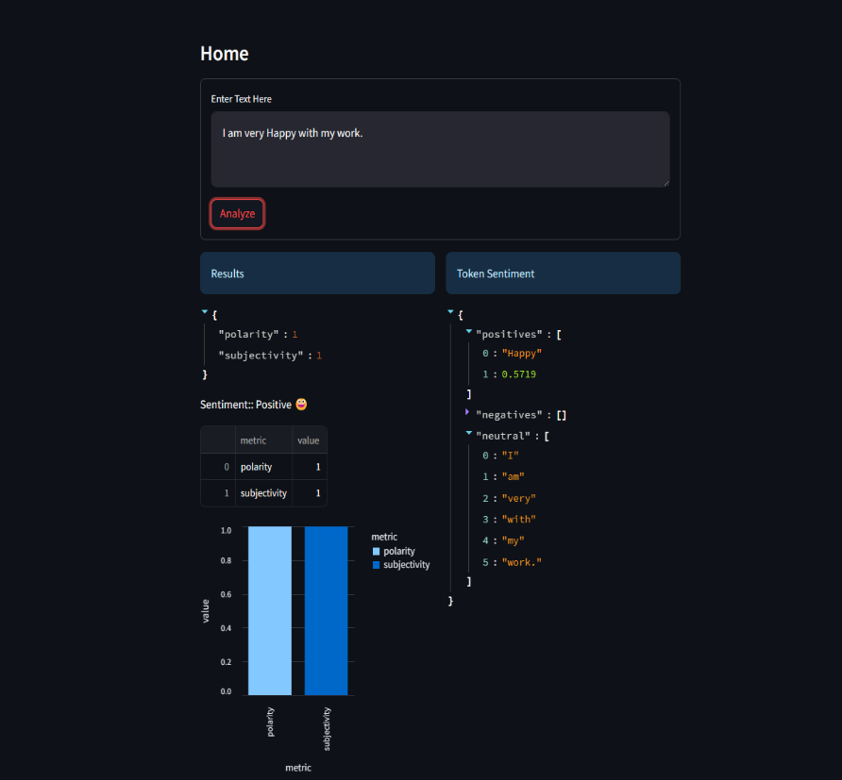

Fig. 12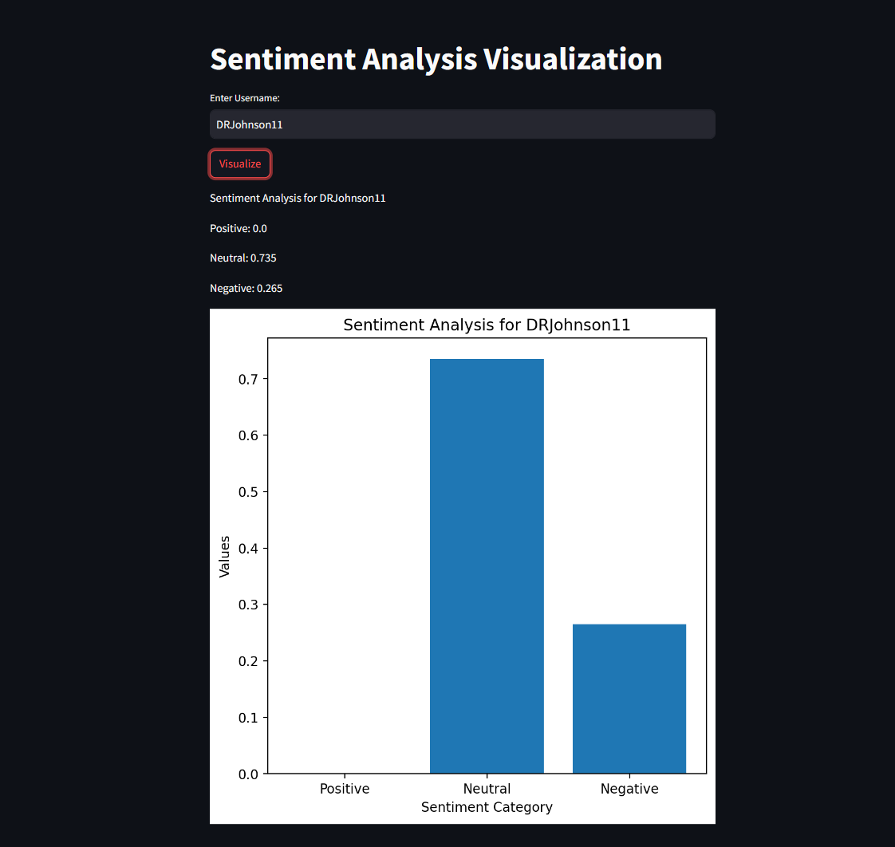

Fig 13

# CHAPTER 7

# CONCLUSION & FUTURE SCOPE

**7.1 Conclusion**

In conclusion, sentiment analysis has emerged as a crucial tool for businesses, organizations, and researchers to gain valuable insights from the vast pool of textual data available on social media platforms. By systematically analyzing and categorizing sentiments, emotions, and opinions expressed by users, sentiment analysis provides numerous benefits, including a deeper understanding of customer preferences, improved brand management, and enhanced customer engagement. It allows businesses to proactively manage brand reputation, identify emerging market trends, and make data-driven decisions to stay competitive in the dynamic business landscape.

Furthermore, sentiment analysis serves as a powerful means of detecting and addressing potential crises in real time, enabling timely and effective crisis management strategies. By leveraging sentiment analysis, businesses can improve their products and services to better align with customer needs and expectations, thereby fostering stronger customer relationships and loyalty. The insights gleaned from sentiment analysis not only help businesses tailor their marketing strategies but also facilitate informed decision-making for long-term business success and growth.

Overall, sentiment analysis plays a pivotal role in empowering businesses to listen to their customers, understand their sentiments, and respond strategically to their feedback. With its ability to uncover hidden patterns and trends, sentiment analysis has become an indispensable tool for businesses seeking to stay relevant, competitive, and customer-focused in an increasingly interconnected and digitally driven world.

**7.2 Future Scope**

1. **Customer Feedback and Support:** Sentiment analysis can help businesses in understanding customer feedback on social media, allowing them to improve products and services and provide more efficient customer support.
2. **Brand Monitoring:** Companies can use sentiment analysis to monitor their brand's reputation online. They can track mentions and gauge public sentiment to adapt their marketing strategies.
3. **Product Launches and Campaign Evaluation:** Sentiment analysis can be used to assess the reception of new products or marketing campaigns, allowing for quick adjustments based on public sentiment.
4. **Content Creation and Curation:** Content creators can use sentiment analysis to understand what topics and themes are currently popular or resonate with their audience, helping them create more engaging content.
5. **Trend Analysis:** Social media sentiment analysis can help individuals and businesses identify emerging trends and capitalize on them, whether it's in fashion, technology, or entertainment.
6. **Event Monitoring:** Sentiment analysis can be used to monitor and evaluate the public sentiment around events, from sports matches to political rallies, aiding event organizers and sponsors.
7. **Influencer Marketing:** Brands can use sentiment analysis to identify influencers whose values and sentiments align with their products or services, leading to more effective influencer partnerships.
8. **Public Health Monitoring:** Public health agencies can use sentiment analysis to monitor public sentiment around health-related topics, helping them respond to public health crises and misinformation.
9. **Travel and Tourism:** Sentiment analysis can help the travel and tourism industry understand how tourists feel about their destinations and services, leading to improved experiences.
10. **Job Market Analysis**: Job seekers can use sentiment analysis to gauge the sentiment of a company's employees and its work culture, aiding in job selection.

**Bibliography**

1.Pang, B., & Lee, L. (2008). Opinion mining and sentiment analysis. Foundations and Trends® in Information Retrieval, 2(1-2), 1-135.

2, Liu, B. (2012). Sentiment Analysis and Opinion Mining. Synthesis Lectures on Human Language Technologies, 5(1), 1-167.

3.Thelwall, M., Buckley, K., Paltoglou, G., Cai, D., & Kappas, A. (2010). Sentiment strength detection in short informal text. Journal of the American Society for Information Science and Technology, 61(12), 2544-2558.

4.Agarwal, A., Xie, B., Vovsha, I., Rambow, O., & Passonneau, R. (2011). Sentiment analysis of Twitter data. In Proceedings of the Workshop on Language in Social Media (LSM 2011) (pp. 30-38).

5.Go, A., Bhayani, R., & Huang, L. (2009). Twitter sentiment analysis. In Proceedings of the International Conference on Weblogs and Social Media (ICWSM 2009) (pp. 1-3).

6.Cambria, E., & Hussain, A. (2015). Sentic computing for sentiment analysis: Multilingual sentiment ontology and analysis engine. Web Intelligence and Agent Systems: An International Journal, 13(3), 247-265.

7.Pak, A., & Paroubek, P. (2010). Twitter as a corpus for sentiment analysis and opinion mining. In Proceedings of the Seventh International Conference on Language Resources and Evaluation (LREC 2010) (pp. 1320-1326).

8.Hutto, C. J., & Gilbert, E. (2014). VADER: A parsimonious rule-based model for sentiment analysis of social media text. In Eighth International Conference on Weblogs and Social Media (ICWSM 2014) (pp. 216-225).

9.Liu, B. (2015). Sentiment analysis: A comprehensive review. In Proceedings of the IEEE Conference on Big Data (Big Data 2015) (pp. 2472-2480).

10.Mohammad, S. M. (2016). Sentiment analysis: Detecting valence, emotions, and other affectual states from text. Emotion Measurement, 2016, 201-237.